**QNO1. CREATE EMPLOYEE TABLE?**

**ANS:**

create database employeedetails;

use employeedetails;

create table empl (

empno int,

ename varchar(15),

job varchar(15),

mgr int,

hiredate date,

sal decimal (10,2),

comm decimal (10,2),

deptno int );

insert into empl values (8369,'SMITH','CLERK',8902,'1990-12-18',800.00,null,20),

(8499,'ANYA','SALESMAN',8698,'1991-02-20',1600.00,300.00,30),

(8521,'SETH','SALESMAN',8698,'1991-02-22',1250.00,500.00,30),

(8566,'MAHADEVAN','MANAGER',8839,'1991-04-02',2985.00,null,20),

(8654,'MOMIN','SALESMAN',8698,'1991-09-28',1250.00,1400.00,30),

(8698,'BINA','MANAGER',8839,'1991-05-01',2850.00,null,30),

(8882,'SHIVANSH','MANAGER',8839,'1991-06-09',2450.00,null,10),

(8888,'SCOTT','ANALYST',8566,'1992-12-09',3000.00,null,20),

(8839,'AMIR','PRESIDENT',null,'1991-11-18',5000.00,null,10),

(8844,'KULDEEP','SALESMAN',8698,'1991-09-08',1500.00,0.00,30);

select * from empl;

select ename,sal from empl where sal >= 2200;

select empno,ename from empl where comm is null;

select ename,sal from empl where sal between 2500 and 4000;

select ename,job,sal from empl where JOB <> 'MANAGER';

select * from empl where ename like '__A%';

select * from empl where ename like '%T';

**CREATE EMPLOYEE TABLE.**

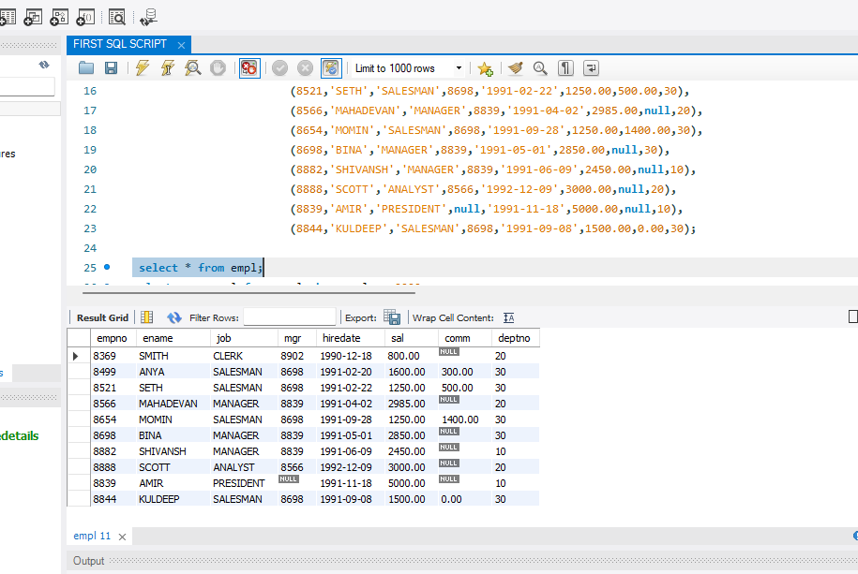

1. **WRITE A QUARI TO DISPLAY THE ENAME SAL AND ARE GREATER THAN EQUAL TO 2200?**

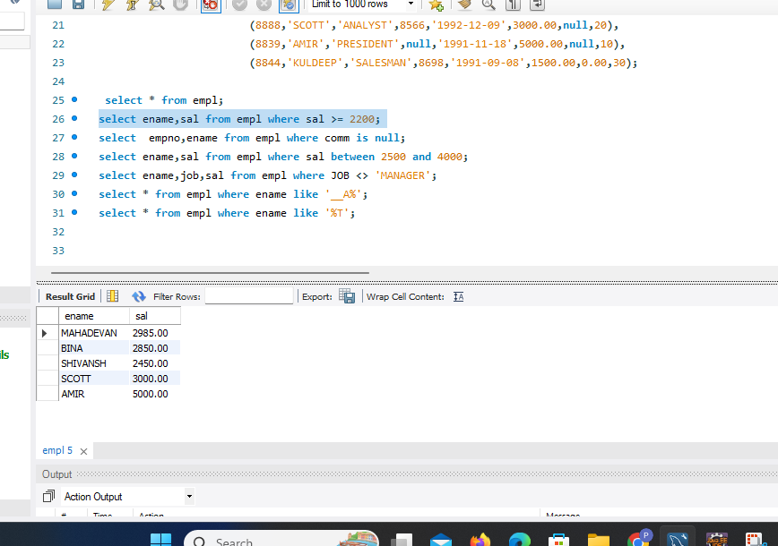

2.DISPLAY EMPLOYEES WHO ARE NOT GETTING COMMISSION?

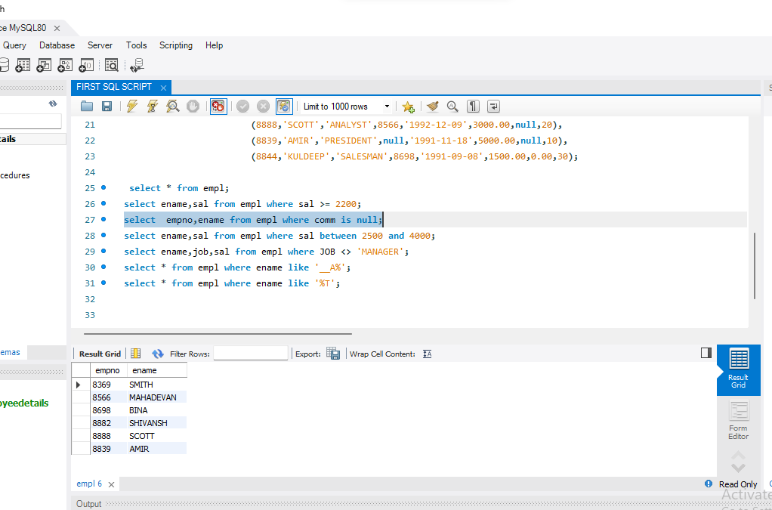

3. WRITE A QUARRY TO DISPLAY O EMPLOYEE NAME SALARY WHO DON'T HAVE THEIR SALARY INTHE RANGE OF 2500 TO 4000?

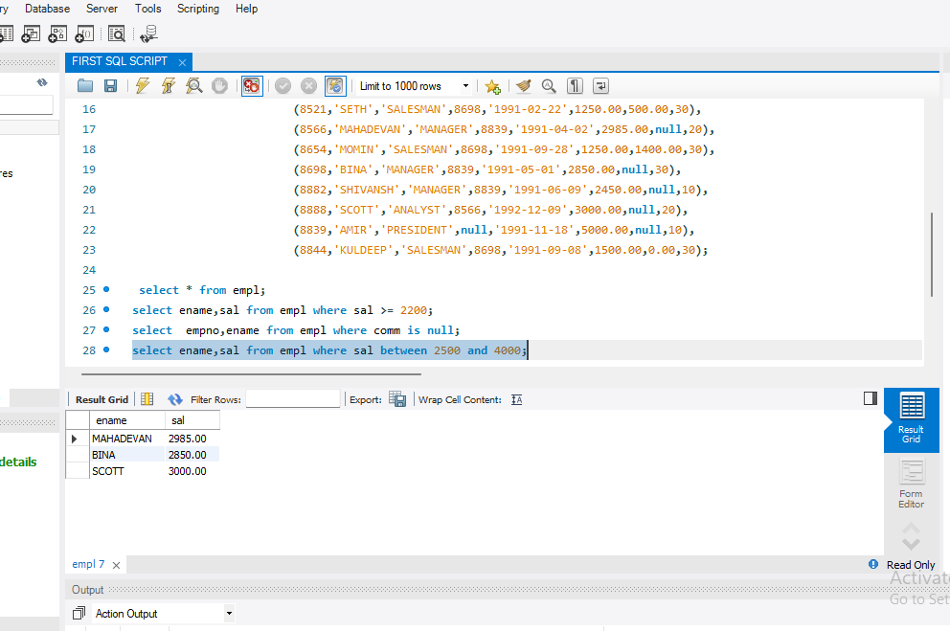

4.DISPLAY NAME JOB TITLE AND SALARY EMPLOYEES WHO DON'T HAVE A MANAGER?

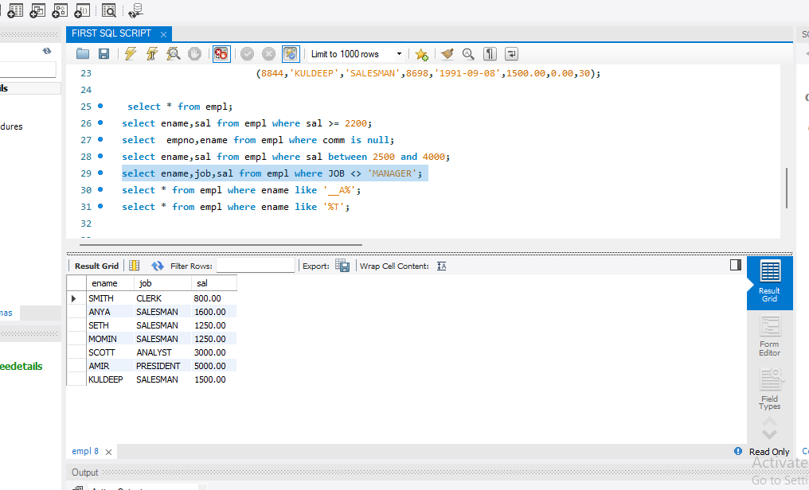

5.DISPLAY EMPLOYEE NAME WHOSE NAME A AS THIRD LETTER?

ANS::  **select * from empl where ename like '__A%';**

IN THE EMPLOYEE TABLE DON'T HAVE ANY NAME THIRD LETTER

AS ‘A’.

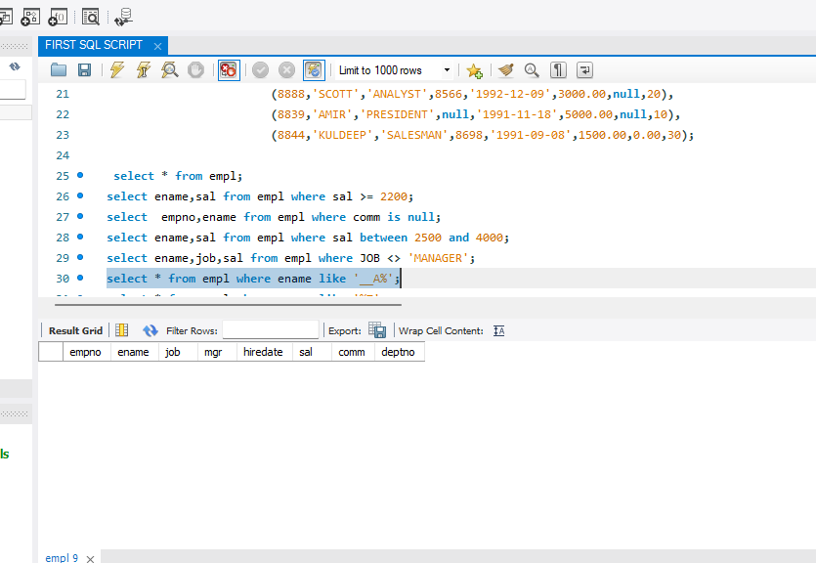

5.DISPLAY EMPLOYEE NAME WHOSE NAME ‘T’ AS LAST LETTER?

